Extent of Digital Inclusion in Sundarbans Region of West Bengal
Binoy Majumder
(April – June, 2018)
Background
India is striving to connect its governance, public services and citizen on the digital platform. Various public services like banking, tax form filing, registration process for education, ticketing for transportation, gas connection and refilling etc. has brought to the digital platform for achieving a seamless and transparent service. Huge technological advances in the field of telecommunication and information technology were witnessed in recent years. Smart phones are available in a wide price range, making it affordable for rich, and even poorer households. Thus bringing the technology of computing and data accessibility to the grass root level. Data accessibility has become cheaper via smart phones and SIM based internet connection. People are using more data than ever.
- Objective of the study
The state of West Bengal also consists of a number of regions from the hills in the north to the Bay of Bengal in the south. This study is conducted in the southern-most part of the state situated in the coastal region of the state and comprised of numerous islands with little or no road connection with the mainland. This coastal area, popularly known as Sundarbans and declared as World Heritage Site by UNESCO, lies across West Bengal and Bangladesh and is inhabited by a large number of impoverished people. The total population in the Indian part of Sundarbans, consisting of 102 islands, has crossed 4 million by 2011. This study is intended to understand the typical character of changes in consumption pattern that is taking place in one of the most inaccessible part of the country largely unaffected by the rapid urbanization taking place in other parts of the country and inhabited by one of the most economically disadvantaged sections of our population.
Objective of this paper is to understand the following factors in achieving digital inclusion of these villages in the age of information communication and technology. (i) Ownership status of digital devices among the villagers, (ii) Current status of network availability for accessing and sharing data, (iii) Status of electrification, and availability of power to access internet from devices, (iv) Community’s ability to understand the language of internet and ability to surf though websites. This study tried to understand whether the ownership of smart devices and data connectivity has been successful to provide the community members command over utilizing the benefits of digitalized governance and various public services.
This paper is based on a field study conducted in four villages in two blocks of Sundarbans. All four villages are situated in islands and lacks the road connectivity with Kolkata and other township.
Sundarbans is a uniquely geographically situated regions in West Bengal. In spite of being within 100 km away from a metro city, this region is in general underdeveloped due to the presence of large rivers and lack of road connectivity. Ayla cyclone in 2009 had destroyed all kind of traditional livelihood options and triggered huge migration of mostly construction labour force to big cities in different States in India. Government’s initiative to ensure basic food security and the flow of remittance from the migrant family members have improved the economic condition of families of Sundarbans. Intra-island road condition has constantly improved for last couple of years, giving better exposure of local markets to modern commodities as well as electronic gadgets. Migrant members in different cities witnessed the ongoing change or electronics worlds and themselves took part in it. When they visited their families, they brought budget phones and set a trend of gadget ownership tendency among the remaining villagers, especially the younger generations. Progress in the world of android technology enabled them with ability of purchasing smart phones. During last couple of years, data price on SIM based internet facility has triggered a huge influx of smartphone ownership and data use. Out rich of dish TV network has also played an active force to create a smart gadget demand and data use.

- Study location
Four villages are selected from two blocks, namely Gosaba and Hingalganj, situated in South 24 Parganas and North 24 Parganas districts respectively. Although situated in two districts, both the blocks fall in the same Sundarbans regions with many common characteristics determining the socio-economic conditions and consumption behavior of the local population. Both the blocks are inaccessible by road and although not far away from Kolkata, remain mostly unaffected by the waves of urbanization. Both the blocks are around 85 kms away from Kolkata city.
The livelihood of the local population was traditionally dependent mostly on agriculture, fishery and collection of forest produces. Due to severe lack of irrigation, farmers here mostly grow the single crop, Aman paddy, depending on the monsoon, which is erratic in nature affecting the production of the crop frequently. Further, the agricultural and homestead lands are affected by river erosion and frequent flood. The greatest loss to lives and livelihood took place in the year 2009, when a cyclonic storm Aila devastated the whole region with saline sea water flooding most of the coastal areas including the agricultural lands and sweet water ponds. The lives of the Sundarban inhabitants did not remain the same after Aila that forced huge migration of the working people to cities and urban areas.
Electrification of these villages started to take place after 2012-13. Electrification of Bijoynagar villages started from 2017. Though electric connection was done in all the villages in our study islands, not all the households are not yet electrified. Use of smart phone is very common in this region. About 30-40% of the households have smart phones.
District | Block | Village | No of respondents
South 24 Parganas | Gosaba | Bijoynagar | 20
 |  | Malopara (Arampur) | 20
North 24 Parganas | Hingalganj | Kalitala | 20
 |  | Haridaskati (Samsernagar) | 20
Total |  | 4 Villages | 80
Position of study villages in Map:
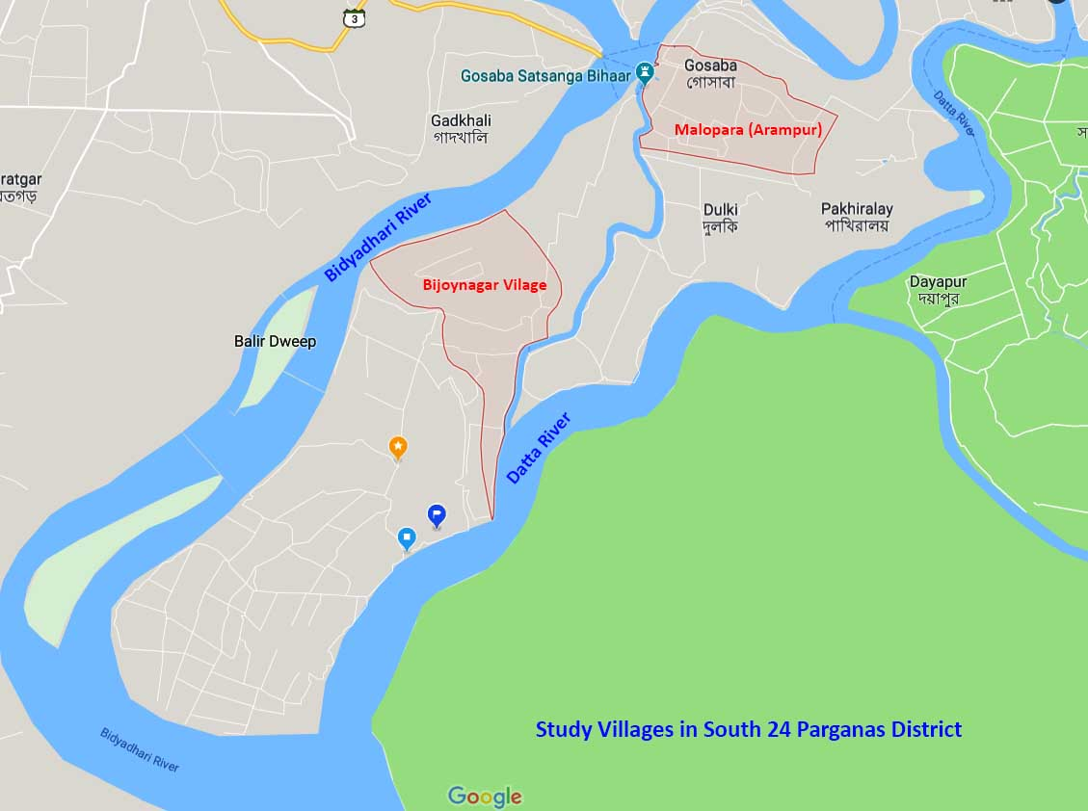
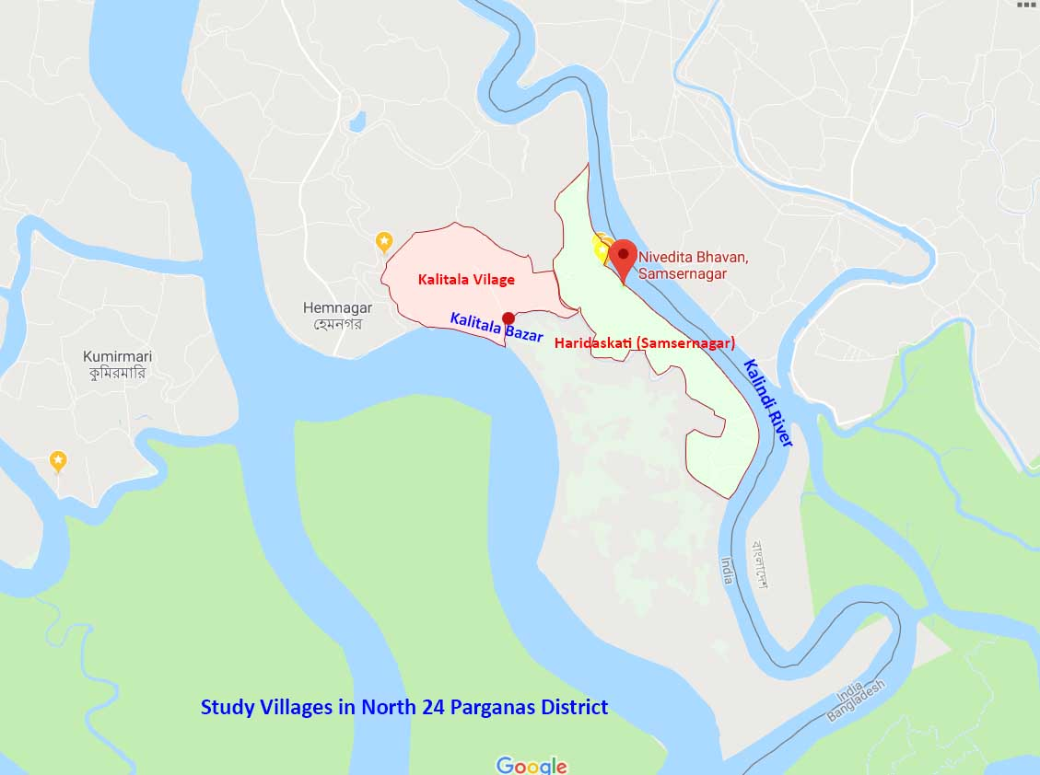

- Study methodology
The study was conducted in South 24 Parganas and North 24 Parganas districts. Gosaba block from South 24 Parganas, and Hingalganj Block of North 24 Parganas was selected. 2 villages from each of these blocks were selected as study villages. 20 smart phone owners from each villages were interviewed with a set questionnaire.
- Demographic details of the Respondents:
20 smart phone owners each from four villages were selected for the interview. Respondents were randomly resected from different occupation and educational backgrounds.
i) Number of respondents as per gender:
Gender | No of respondents
Female | 26
Male | 54
Total | 80
ii) Number of respondents as per religious belief:
Religion | No of respondents
Hindu | 69
Muslim | 10
Others | 1
Total | 80
iii) Number of respondents as per social catagory:
Social catagory | No of respondents
General | 15
Schedule Caste | 40
Schedule Tribe | 0
OBC | 15
Total | 80

iii) Occupations of respondents:
Occupation | No of respondents
Studying | 28
Salaried Job | 11
Wage Labour | 12
Business | 5
Cultivators | 2
Home Makers | 8
Unemployed | 9
Others | 5
Total | 80
- Findings of the Study :
- Network Status in the study area:
Network quality in this region is found to be in a bad state in general. 32% of the respondents reported stable network and 68% reported unstable network. While it was found that almost half of the total sample size are using Airtel, 49% of the sample size; only 5% of them use to get 4G network, 5% get 3G network, and the rest 90% of the Airtel users reported very slow and unstable 2G network. It was found during our discussion with local mobile shop owners and recharge centers that signal strength of this particular network provider has deteriorated during last 2 years.
29% of the respondents use Vodaphone. They reported a slightly better picture. 26% vodaphone users get 4G network, 35% gets 3G, while the rest 39% gets 2G network.
Reliance Jio is a comparatively new player in this region. They comprise of 17% of the total respondents. 50% of them reported good single, while 50% reported bad and unstable network.
Idea users are very few in number while BSNL has no network connectivity in this region.

Present status of data network in study villages
Status of Network | No of responses
Stable | 26
Unstable | 54
Total | 80

Quality of available data network in study villages
Strength of Network | Total No of Users
4G | 15
3G | 11
2G | 54
Total | 80

- Electrification Status of the Study area:
Electrification is done in all the 4 study villages. Electrification of Arampur Malopara, Kalitala, and Samsernagar Haridaskati village started a couple of years back. But electrification process in Bijoynagar village started from 2017. All the households is not yet given electric connection. 70% respondents reported that over 75% households in their locality (para) were given electric connection. 31% reported 50 to 75% electrification in their locality. 6% reported 25 to 50 % connection, while 6% of the sample size reported that only less than 25% of households of their locality were given connection so far. Charging of mobile with solar panel is done in done in village. While more new families are getting new electricity connection, the condition of electricity supply is extremely bad. The whole study area use to suffer power cut off or an average 2-3 hours a day. Long duration power cut-off for 1-2 days in a row use to happen every time after heavy rain, storm, thunderstorm and other natural calamities which very frequent in this region. Local cyber café owners reported frequent and regular disturbance of all computer related and network related activities due to irregular electricity supply.

- Place of Internet Use:
Use of internet is mostly done at their home and on smartphones. Percentage of female users is higher when they use internet in home. While males showed more tendency to visit cyber café and other places. 11% of males reported that they used internet away from home, while 8% females reported that they used internet at cyber café of other such places.

- Frequency of internet use:
14 out of 80 respondents reported that they have not used internet for last 3 months or it is very rare. These respondents comprise of 5 males and 4 females. Only the network quality seems to be the only deciding factors for this behaviour. 11 of them have smart phone but they use the phone for making phone calls only. Other 3 of them don’t own personal smart phone but they used their family members’ phone for watching streaming of TV programs or for social media. Only deciding factors for making differences in the frequency of internet use is the stability of network in the users’ locality. Out of 14 respondents, 10 of them have reported unstable network connectivity in their locality.

- Type of Internet uses:
It was found during the study that most of the respondents use internet for accessing social media and infotainment channels. While 91% use social media, 86% use infotainment channels, only 55 used it for information and web-searching purpose, and a little 19% use for accessing banking sites or govt. sites. Percentage of males using search engines and accessing bank and govt. websites is higher than female percentage.

- Use of data services by Respondents:
It was found that data use is heavily done for social networking, watching TV programs, movies, sports from YouTube and other infotainment sites. 84% of total respondents use net for pursuing hobbies and leisure. 93% respondents use net for social networking, and 90% use for accessing infotainment sites. Online shopping is a recent trend. But the lack of road connectivity cause delay in delivery which was reported as a drawback for online shopping. Email, job searching or online application submission is done on a very small percentage. I case of job searching and application submission, more males are participating than female respondents.

- Ability of internet use:
Female respondents showed better performance in doing basic operations like turning on or off the smart devices and computers. But they showed lower performance in logging into a network or navigating through internet and kind. While 69% of male respondents reported that they can understand the language or website only 31% of female respondents have ability to understand. 65% males can creatively use words for information searching, while only 31% female can do that.

- Using Internet for availing Govt. services and benefits:
Using internet to apply for public services and benefits is still limited. Internet based rail ticketing is used by migrants labour and they take help cyber café situated at the block markets. Girl students have to fill online forms to avail the benefit of Kannyashree scholarship program by the State Government. Services of this kind, like filling up those forms, looking for board examination results, availing caste certificates, applying for college admission, filling up job forms are provided by computer literate local people who have set up cyber café at local markets. They also provide services like finding land records, applying for new electricity connection, payment of electricity bill. In the recent event of Gram Panchayet election of West Bengal, election contestants submitted their nomination form with the help of such local cyber café. Our discussion with cyber café owners reveled that they use SIM based networks to use internet, and their works is heavily hampered because of network instability. Usually one café owner keeps several SIM cards from different carriers, and use one of them which gives best signal strength at the particular moment of need. Transaction failure during online payment for rail ticket, electricity bill payments; loosing net connectivity during form fill up, college admission is a common issue. These café owners were given informal training by the BDO office to prevent any unfair activity, cheating of the customers, and ensuring a smooth way of availing public services by filling the online forms properly and submitting proper documents.
Online banking is limited to the use of Paytm apps, which is used by young generation for the purpose of mobile and Dish TV recharge purpose. Applying for new bank accounts and kind is done at the Grahak Seva Kendras of the bank.

- Internet Using Experience:
Due to the instability of network signal, accessing any website is a time-consuming task for the users. Their experience of opening a simple website, like a search engine, was asked. Only 24% of the total respondents reported that they can easily open a website on their smart device(s) without roaming about in search of a place where they can get better network. For 34% users, it takes a while to open sites. For 31% users, it takes longer time, while it is almost impossible to open website inside their house premises for 11% of the users.

- Major Barriers on the way of Digital World for this region:

Unavailability of a stable network is a major barrier for a user to access an online service. It was observed during the study that putting a phone call is a challenging task because of unstable network.
Irregular electricity is another major problem. Frequent and regular power failure hamper the activities of local cyber cafés who provide help for online services like form fill-up, electricity bill payment, land record, scholarship application, caste certificate application, job application etc. Regular power failures bar the inhabitants to do their work in time.
Lack of computer knowledge among the members of families is still a major drawback on the use of online services. 66% of the respondents have mentioned it as the major barrier on achieving a digitization of their activities. The local population is striving to overcome this situation. In this study 55% respondents have reported that they have at least 1 computer literate person in their families. Instructor of a computer training centre at Gosaba Bazar has reported that girls are showing more interest in computer learning than boy students. Though, boys are more in number in getting admitted to a computer course, girls are more successful in term of completion of the course.
High Schools have computer laboratory. But the classes are irregular and computers in the laboratory are mostly in functional. Therefore, young learners have to get admitted to a private computer for getting a basic working skill.

Respondents were asked whether they have personal mail id which is one of the basic requirement for a user to avail any kind of online services. Out of total 80 respondents, 47 respondents have a personal email id, while 33 of them don’t have. Percentage of female respondents who have email id is far lower than male respondents. Out of 47 email id owners, 83% reported that they used it for filling up online forms and other important works, while 17% of them have created email id for having a google account and operate the smartphone.

39% respondents have reported that they observe high influence of internet on their daily activities, 36% have reported the influence as moderate, while the rest 25% reported no influence.

91% respondents think that the digitalization of different govt. services, application, form fill up, banking etc. have made the life of the islanders easier than before. Applying for a caste certificate would have taken a whole day earlier, now visiting any cyber café and taking their service against a uniform payment (throughout the market) has reduced the time to half of the day. 8% respondents think that it has brought no change in respect of easing out the process. 1% of the respondent think that bringing everything on a digital portal has made the process complicated and out of reach for the population of Sundarban, as they have to depend upon cyber café owners and those who know internet and have computer knowledge. In general all the respondents opined that spreading of computer knowledge is required to make the digitalization initiative successful.
Inference:
Ownership of smart devices and data use have increased. But the use of smart devices by the owners remain restricted to use of social networking and watching infotainment channels. Only a few owners were able to take larger benefit of a smart device by using it beyond social networking and watching infotainment sites. Network and electricity instability is the major factor barring the use of data. While, the lack of computer knowledge, users’ inability to understand the language of sites in the most deciding factor for not using the existing benefits to its full potential.

The Researcher, Kolkata

