Tata trusts and vikas anvesh foundation
Digital Financial Inclusion
Overview of shortcomings
Dr Ved Prakash Gulati
Kishore Kumar Paidimarri

This paper talks about the extent of Digital Financial Inclusion in India. Digital Inclusion is a proven technology solution that can catapult development into a faster orbit. Though it has grown enormously due to various measures by the Government, financial institutions, but it has so far been not able to attain its potential due to several reasons. Government of India expected banking to spread using technology and bring several hitherto uncovered into the development fold but the technology alone has not helped the cause. Some reasons, concerns and solutions are discussed in the paper

Digital financial inclusion- Role of banks and other financial institutions

Introduction
To appreciate the importance of digital financial inclusion, let us examine the small case:
Ramu works in a brick kiln in karimnagar of Telangana. His employer pays Ramu’s salary once in two months. Today Ramu has received his amount and wanted to send it back home in Keonjhar, Odisha where his family lives. He went to an agent in Karimnagar who transfers money. He transferred Rs 13500 home. Because it was an instant transfer, he was charged with Rs 775 by the agent as the standard fee was 5% of money transferred. When he was leaving the agent’s shop, he has seen a poster of Prime minister with words “Jan Dhan Yojana- Sabka apna bank khata” written in Hindi. Looking at it, he smiled within himself because he has opened that account but has not been able to use it since then because he migrates to Telangana 8 months in a year and is paid in cash by his employer. He had mobile application; internet banking and ATM card also but did not use them because mobile application and internet banking were out of his reach to understand and ATM card was stuck in machine last time leading to four days loss of his time in getting it back. He was also charged for attempting more than five transactions whereas he tried those options in trying to understand the process.
Today when vegetable vendors and tiffin centres have Paytm, when he sees his employer using credit card to pay for his daughter’s toy, he is left wondering having not known and also fearing update in technology.
This case highlights the changes that technology has brought to banking, throws light on what people could do in a better way and also points out at difficulties faced by people in understanding technology.

Background

Inclusion:

India is moving from underdevelopment to development. In this process, several people are left behind due to various reasons. In order to make them part of the process, there are several development programs undertaken by the Government. All these programs aim to improve the life of the poor. This is inclusion. There are levels of filters that apply in terms of access to these schemes. To remove those filters is the main essence of any reform in the schemes for poor.

Digital inclusion:
There is digital explosion everywhere and technology developments are revolutionising every stream of life. The advent of smart phone and data has improved access to information. With this information, people are developing on their ideas and establishing entrepreneurial ventures and succeeding in life. But the limitations here are availability of technology is subject to smart phone and data availability. In order to create a common platform and opportunities for the unreached and underserved to gain access to the technology, Government and industry is making improvements to the existing process. This process is called digital inclusion.

Financial inclusion:
Several lending sources have come up in urban areas leading to availability of affordable capital. Taking this as an advantage, several new types of businesses are taking shape and are creating their own platform for development and employment. Uber, Ola, Urban Clap, Swiggy etc. to name a few of them. At the same time, procedural requirements have limited these institutions to largely urban areas leading to a large untapped potential of rural India being left out. Government of India and financial institutions have conducted a process re engineering and with the help of technology developed themselves at a stage where they can be accessed easily. This will help finances reach the unreached. This is called financial inclusion.

Digital Financial inclusion:
Using digital advances and leveraging flexible procedures of financial institutions to bring the finance and banking to the door step of the unreached and the underserved is digital financial inclusion and is a vital requirement for fast tracking India’s developmental efforts.

Present status:
The traditional banking and traditional financial lending institutions have not been able to succeed fully because they could not tap the complete potential at any point of time. Due to this these institutions have excluded several of those sections of society which really required their services. Some reasons for this are:
- Complex process of accessing to a bank account or capital leading to cost implications for the service providers and the consumers equally
- Difficult interpretation of rules for semi literate and illiterate, leading to misinterpretation
- Banks and financial institutions are sparsely located in rural India, making it a time consuming affair to bank on them
- Working hours and holidays of these institutions make it further difficult for people to operate
- Language of communication like forms to be filled is mostly in English, preventing most of the Indians from access.
- All this came at a high cost since consumers were less but staff and technology had to be maintained prompting banks to levy transaction charges.
It has been long identified that technology can fast track the effort of taking banking to the door step. World bank has emphasized the same in their studies published from time to time. Increase in digital aid for financial inclusion is seen in a long term point of view to contribute in several ways like:
- Bring the underserved and unreached closer to financial inclusion
- Make finance available to the needy
- Increase GDP of nation by enabling entrepreneurial decisions by the people with availability of affordable finance
- If all money flows into the account of an individual and they spend from their accounts, people are inevitably saving money in account till they spend. This inculcates saving as a default habit which can improve overall deposits phenomenally
- Keep a tab on informal lending institutions from charging exorbitant rates of interest
- Record most of the financial transactions and reduce tax burden on selected sections of people by uniformly distributing it across the nation

Response of financial institutions to technological advances
Taking a cue from this, banks and financial institutions have introduced several technological changes like:
- Core banking solution
- Digital wallet
- Mobile, telephone and internet banking
- Branchless banking through kiosks where money, cheque etc can be deposited and withdrawn also.
- Seamless and same day transfer from account to account
All these efforts led to decrease in transaction cost and time, reduced complexity, increase in transparency, safety, security and digital recorded evidence leading to enhanced accountability. With these developments financial institutions have reduced the need for physical presence thus making it easier to reach the door step of the underserved and unreached. Banking and financial set up was now flexible enough to be done by a feature phone, on a smart phone application or on an internet connected tablet.

Response of government to technological advances
Government of India has realised the potential in integrating digital technology with banking and has taken several measures to take banking to the doorstep of the needy and the underserved. Some of the measures taken by the Government are:
- Enabling single identity card (Aadhar) for opening and operating bank account.
- Introducing e governance leading to several departments of government keeping all the information available online.
- Introducing digital, mobile and phone banking
- Facilitating bank account linked payments for most of the works undertaken
- Placing upper limits on handling cash to digitize the economy and incentivising people for using digital payments
- Introducing direct benefit transfer for several schemes like subsidies, scholarships and payments for wage labourers etc
- E- procurement policy and e-tendering for government related purchases
- Online applications for several exams with payment linked to either internet banking or payment gateways
- Developing UPI linked app to facilitate payments even from feature phones through SMS gateway
- Demonetization of Rs 1000 and Rs 500 notes to encourage plastic currency use and online payments
In continuation to this, government has incentivised payments online through discounts and nullifying service and convenience charges that were charged earlier. A large campaign has been organized to promote digital India which advertised several benefits of banking digitally and transacting digitally. The more these services are accessed by the consumers, the cheaper it works out for the institutions and thereby transaction charges can be reduced to minimum possible extent. All these attempts were aimed at providing the following benefits to the consumer:
- Take banking as close to the unreached and underserved household as possible
- Reduction in transaction time allowing focus on other activities
- Inculcate saving in bank account as a habit
- Increase in awareness on banking so that more people involve in direct banking
- Facilitate several other payments linked works in a seamless and transparent manner
- Reduce the role of financial intermediaries by providing access to direct banking

Digitization efforts of financial institutions in detail:
Banks have taken to a massive leap in terms of introduction of
- Core banking (permitting banking at any branch for an account holder),
- Internet banking (all transactions done from a branch can be done online now),
- Mobile banking (some key transactions can be done from smart phone through a mobile application),
- Phone banking (basic transactions can be done through IVRS enabled banking through feature phone also).
- Introduction of Automatic Teller Machine-ATM to support several transactions like deposit and withdrawal of money, payments etc.
All these have reduced the need to visit branch and it is a massive step in taking banking closer to the door step of the underserved. Introduction of banking to the self help group movement has led to growth of Micro finance institutions in India. Aided with a working internet, these tools can become very useful in fulfilling the aspirations and digital financial inclusion objective of the Government.

Barriers in digital financial inclusion
Despite all these measures, the banking still lags behind by a wide margin in reaching its objective. It has a set of barriers to overcome in order to be able to penetrate and serve the needy as envisaged by the government. These are:
- Availability and stability of internet connection: Despite several operators claiming their presence all over India and in remotest of places, the fact that comes out through the entire discussion around the tele density and internet availability is that of availability of all season all weather network and stability of internet connection provided by such network.
- Less penetration of smart phones: Availability of several low cost options has made smart phone increase at a great speed but this is still insufficient with approximately 30% smart phone users only from among the population that uses mobile phone.
- Lack of awareness of procedures in availing existing facilities: Though the digital measures are in place, communication to people has at most been information and not educative. Communication that is informative only informs and it is difficult for the rural and urban poor to understand the procedures and implement them.
- User friendly process of banking: Often the process to be followed in a two-step or three-step method. It is this way for security reasons. But it makes operation very difficult for several sections of the society
- Language barriers in accessing banking applications: All the banks were expected to create internet banking in vernacular language in order to take it closer to their consumers. Based on their presence, every bank needs to convert its content into Hindi and/or a locally spoken language but these efforts are not fruitful as of now and conversions are largely limited to the launch page with rest of the pages in English.
- Fear of cyber frauds: Even after several safety measures taken by banks to keep consumer accounts safe and secure, there have been several instances of their details being stolen and money transferred from consumers’ accounts without their knowledge. This coupled with already complex process of banking makes it difficult to the underserved consumer to repose faith in the internet banking and phone banking.
- Minimum balance and limit on number of transactions: Maintenance of minimum balance has prevented several users from opening bank accounts. All those accounts that were covered under Jan Dhan Yojana by the government of India were permitted to operate for a minimum of 5 transactions as free but charges applicable above 5 transactions.
- Mobile applications are language friendly but internet banking is not: Several banks have designed mobile applications that permit many vernacular languages but except Indian bank, rest of the banks do not have beyond 3rd page in Hindi. Keeping in view the less number of smart phones as compared to feature phones and also the fact that several of the bank customers walk up to banking correspondents for transfer of money, converting internet banking into vernacular languages is the need of the hour rather than mobile banking applications
Some of the bank websites’ and first few pages are posted in Annexure-I for information on the extent of content conversion.

Measures to overcome the existing barriers
If the status has to improve and financial system has to be inclusive, Government and banks will have to coordinate and execute a set of measures with the help of Community and Community based organizations. These are:
- Conduct a planned, designed and implemented campaign aimed at explaining complete procedures of conducting banking in all possible means while staying safe from phishing and cyber trap. This has to keep in mind the diversity of culture, language and low literacy levels of the nation.
- People have to be convinced and comforted Explain the people in detail about benefits of using tele, mobile and internet banking like
  - Convenience
  - Transparency
  - Responsibility
  - Speed
  - Cost and time saved
  - Safe and secure
- For developing content in various languages, Reserve Bank of India can suggest or find solution on a common platform which can be employed by all the banks to make internet banking easy
- Reserve Bank of India or NABARD may suitably be requested to issue guidelines to banking and financial institutions to train the groups of Self Help on conducting banking operations since this is one large group of people which are united under National Rural Livelihoods Mission
- Internet connection and stability issues can be addressed with growing mobile connectivity presence and this effort is already underway to a larger extent. Because the telecom industry in India is in consolidation phase, it is a matter of time that this issue is addressed
- Smart phones are increasing due to presence of several cost effective smart phones but like banking, using smart phones also requires training to the underserved and also the elderly.
- For cyber security and awareness, there has to be a committed awareness campaign yearlong for some years until there is an increase in the usage of the digital banking.
- Security and safety features have to be widely publicised on a nationwide platform to generate confidence among people to use technology and get included in this effort.
- Government need to continue to encourage and incentivise people who use digital solutions. Also Government must accept payments for basic amenities in digital mode only as an initiative so that people pay in digital mode.

Conclusion:
Though the government and banks have employed several efforts and took financial inclusion towards simplification in an attempt to include as many underserved by the use of growing technology, it is still lagging behind the objective by a good distance. To match its objective, there is a pressing need to create massive awareness among users about both the technology and smart device usage. There is also a growing need to speak the language of the people.
In addition, government and financial institutions need to implement measures that generate confidence among users. To encourage intense usage, users should be provided with incentives that encourage usage of digital banking. This will enable us to meet the objective of digital financial inclusion.

End of document

Annexure-I

Indian bank
Indian bank is the most progressive of the lot verified with provision of internet banking in Hindi along with English.
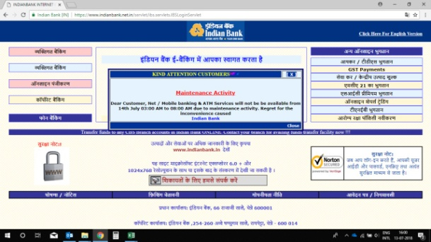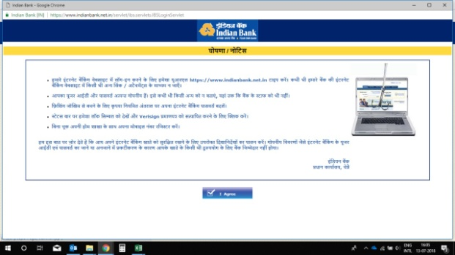
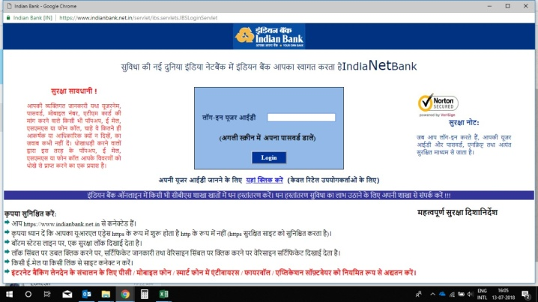

HDFC bank website:
Last level of customization in Hindi is in the form of a webpage. Nothing beyond this is available in Hindi. The same is the case for Marathi. Other than English, these are the two languages for which this document is available. But there is no chance of transaction online in Hindi or Marathi. These are just demo pages.
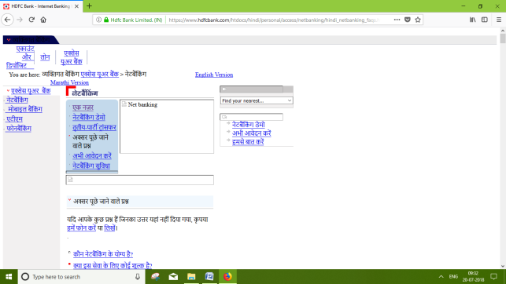
But mobile banking application has Hindi as a language and continues services throughout the transaction in Hindi i.e from login to logout. But the entries are in English, limiting the ability of others.
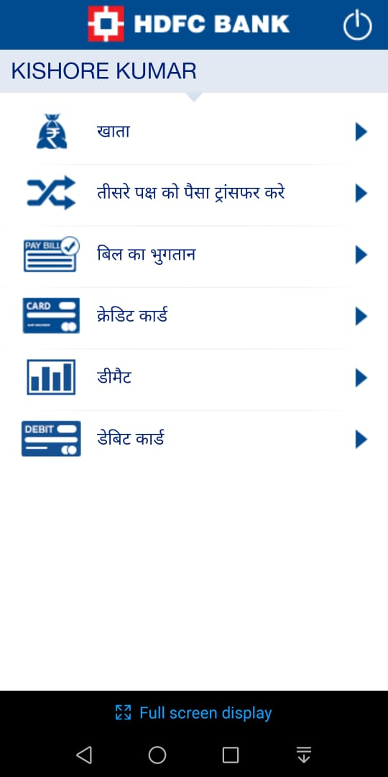
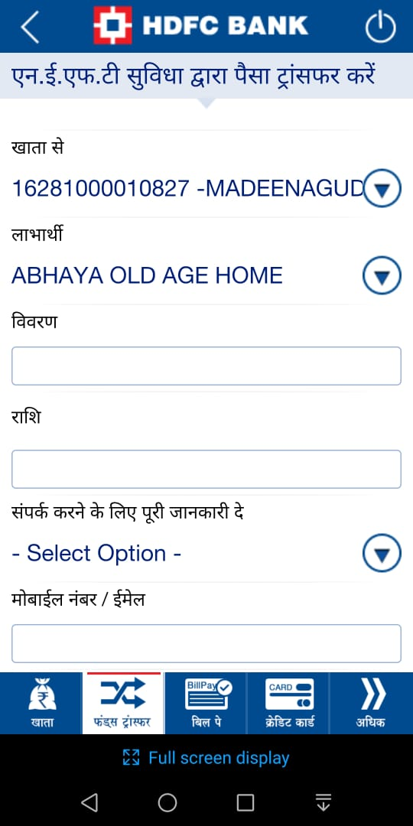
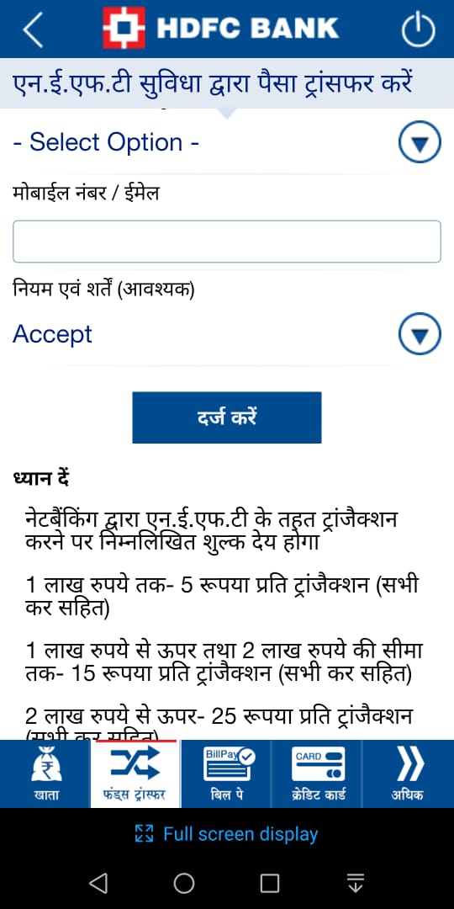

ICICI bank website:
Bank webpage provides information in Hindi but on clicking the link, it takes us to English pages. It does not cover any other language
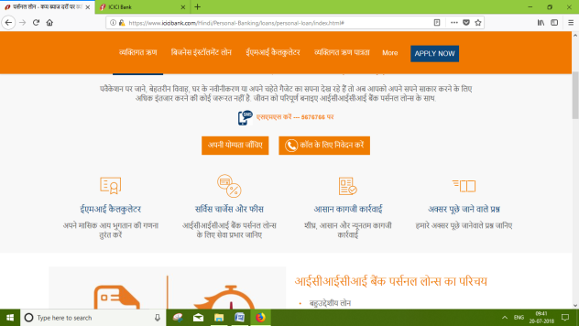
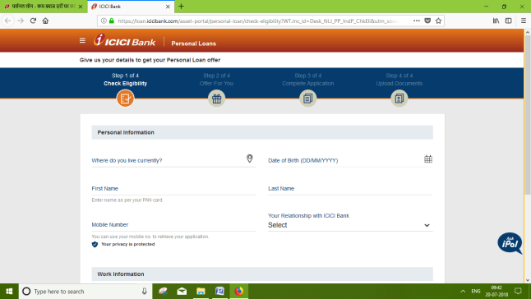
But mobile banking application is available in 11 languages:
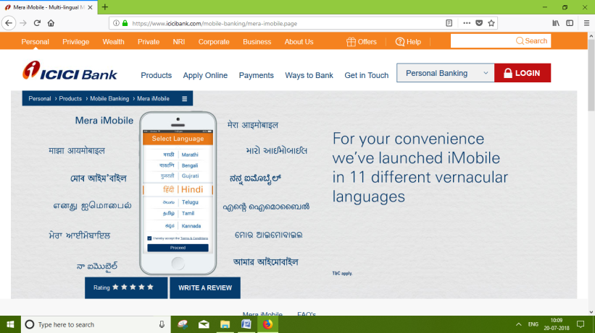

State bank of India website:
State bank of India offers landing page in Hindi and then continues in English. It does not cover any other language
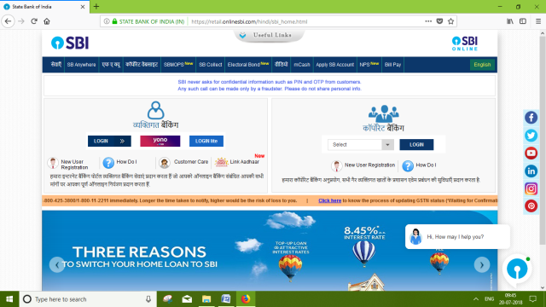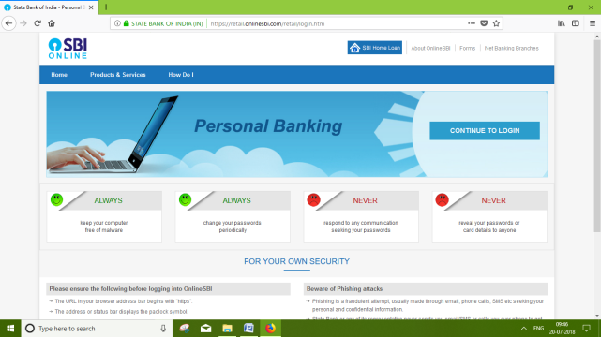
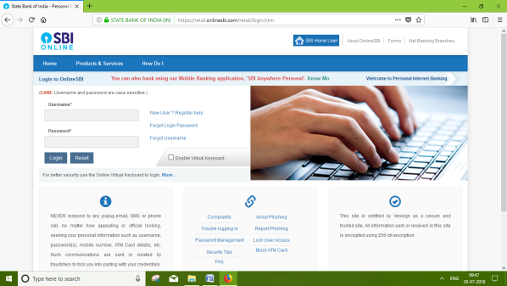

Sbi mobile banking application enables usage in Hindi and English but mobile wallet supports 13 Indian languages.

