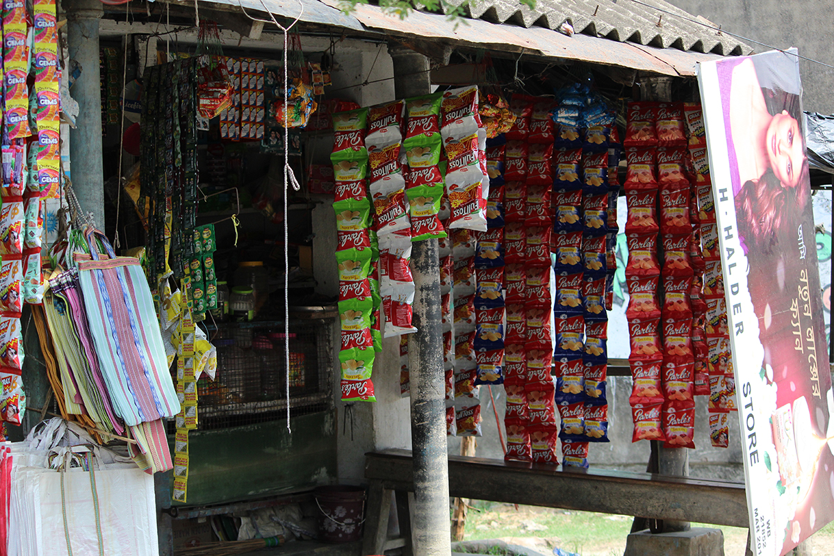  Changes in consumption pattern in the Sundarbans region of West Bengal | Partha Sarathi Banerjee  The Researcher, Kolkata

Study of changes in consumption pattern in the Sundarbans region of West Bengal
Partha Sarathi Banerjee,
The Researcher, Kolkata
- Abstract
Consumption pattern is changing everywhere in India, with the spread of the market economy and the never-ending influx of new products flooding the market even in the remotest corners of the country. This paper is based on a field study conducted in a few remote villages of the Sundarbans area of West Bengal situated on some island blocks in the coast of Bay of Bengal having no road connection with the mainland and is intended to understand the distinctive character of the consumption pattern of the local population in one of the most inaccessible parts of the country where people’s lives are vulnerable to nature’s vagaries, and livelihood option are limited by several factors. The study estimates the present consumption pattern of the local population through a sample survey and tries to capture the perception of changes that took place in the last ten years. The study finds substantial changes in the pattern and quantum of earnings and a resulting change in the consumption pattern of the local population. The study encompasses the local markets as well and finds enormous changes in the market compositions during the last ten years. The study concludes that the fast-changing choices and aspirations of this remote area are leading to complex interactions and underlying tensions between the emerging market and the new generation consumers under the influence of diverse factors like forced migration and exposure to the ever-expanding ad-world. The dynamics between the supply of products in the local market and the demands of the consumers seem to be largely determining the consumption pattern of this area because of its geographical constraint in the flow of products. The study finds that health and education expenses have the largest share (40%) in the present consumption basket, and concludes that infrastructural development and provision of proper health care and good education might substantially change the consumption pattern.
Keywords: Consumption, market, income, migration, food, non-food, packaged food, choices and aspirations, Sundarban.
Acknowledgement: The author acknowledges Vikash Anwesh Foundation, Pune, for their all-around support in undertaking this study and thank Ranjit Kumar Guha, Soma Majumder and Binoy Majumder for their excellent field assistance. The author also extends thanks to the people and panchayat officials for their cooperation in sharing information and data required for the study.
- Introduction
The changes in consumption pattern principally depend on changes in consumers’ taste, preference and income at the micro level and structural shift in the overall environment at the macro level (Amir et al., 2015). Naturally, these factors impacting consumption pattern would vary in different socio-economic contexts and geographical locations. Hence, to understand the changes in consumption pattern, the study must be undertaken in rural India, including the remotest parts of it, where a substantial portion of the population is still living. How their lives are changing? To what extent economic growth of the country is impacting the income and consumption pattern of the local population and what are the factors influencing the changes in their consumption pattern? These are some of the basic questions that this paper aims to examine by field study in one of the remotest parts in the state of West Bengal.
The present study is conducted in the context of several studies undertaken by government agencies and academic researchers, which are mostly based on NSSO data and present the general trend in changes of consumption pattern. The following table shows the nature of change in food and non-food expenditure at the all-India level captured by NSSO surveys spanning from 1972-73 to 2011-12 (Gupta et al. 2016).
Table I: Percentage Share of Expenditure on Various Food and Non Food Items in Urban & Rural Areas (1972-73 to 2011-12)
 | Urban |  | Rural
Rounds | Food Total | Non-Food Total | Food Total | Non-Food Total
27th (1972-73) | 64.5 | 35.5 | 72.9 | 27.1
68th (2011-12) | 38.5 | 61.5 | 48.6 | 51.4

The NSSO survey also shows that the share of beverages in food expenditures has increased from 3% to 13% during this period. This study tries to capture the present consumption pattern in a specific rural location of West Bengal estimating the shares of food and non-food expenditures in the total consumption basket and the shares of packaged food and beverages in total food expenditure. As the exact expenses done ten years ago are not possible to recall, this paper attempts to capture the pattern of changes in consumption over the last ten years by perceptions of the local people.
The four study villages were selected from two blocks, namely Gosaba and Hingalgunj, situated in South 24 Parganas and North 24 Parganas districts respectively. Both the blocks are parts of the same Sundarbans regions having many common characteristics determining the socio-economic conditions and consumption behaviour of the local population. Both the blocks being close to the Bay of Bengal suffers from high salinity both in their soil and water sources. Although numerous rivers and canals surround the islands, sweet water for human consumption and irrigation is scarcely available, affecting the growth of agriculture and economy as a whole in this region. Both the blocks are inaccessible by road and although not far away from Kolkata, remain mostly unaffected by the waves of urbanisation. Both the blocks are around 85 km away from Kolkata city. The nearest township Canning is more than 30 km away.
- Method of study
The principal research instrument has been a structured questionnaire prepared with the aim to capture the present consumption pattern as well as the changes in it that took place in the aftermath of the devastating cyclone Aila in the year 2009. For this study, 60 households were randomly selected from 4 villages, namely Arampur and Bali in Gosaba block and Kalitala and Samsernagar in Hingalganj block. 15 households from each village were administered the questionnaire which was finalised after pre-testing in the field.
For the market study, 30 shop owners from three markets, ten from each, were interviewed with the help of a structured questionnaire. Two of these markets are situated in Gosaba block and the third in Hingalganj block. People of the above villages generally frequent these markets for buying their daily commodities. While the Gosaba bazaar is situated at the block headquarter, the other two markets are situated in comparatively remote locations. Profiles of these markets are captured through a separate set of open-ended questionnaire.
The data collected from the fields are entered into data entry sheets and analysis of the same has been done following standard statistical methods.
The map of West Bengal below shows the location of the study villages.
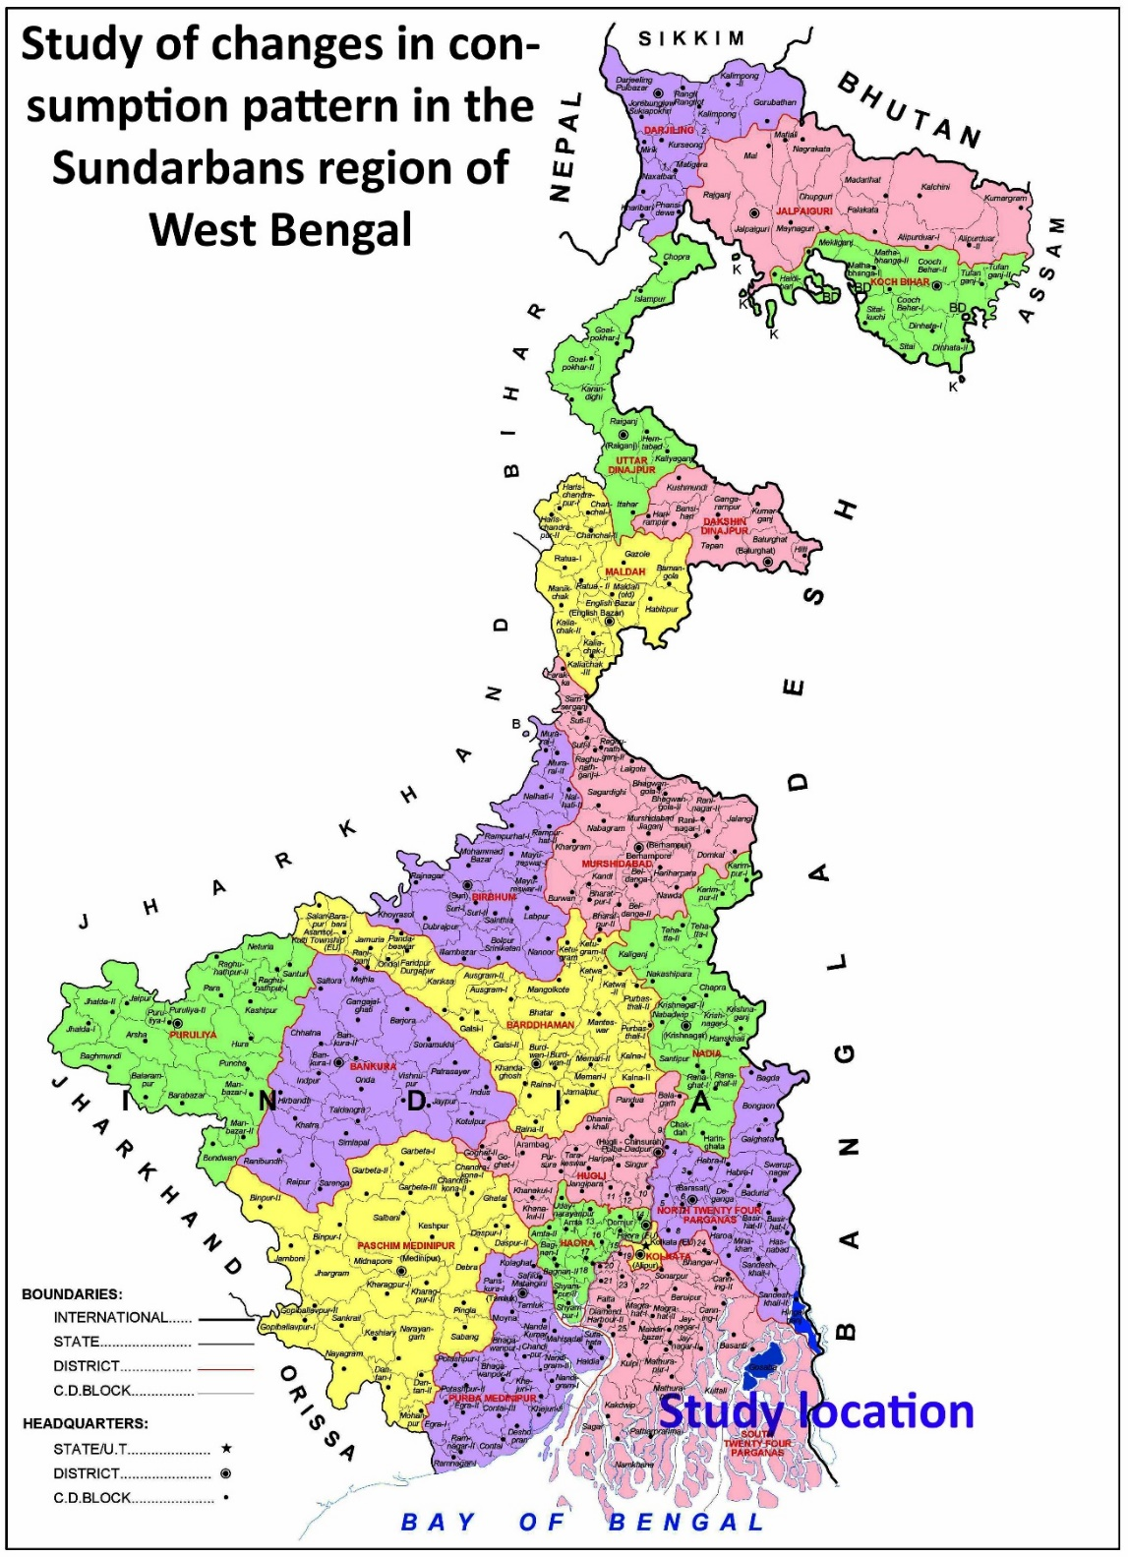
- Findings of the study
- Socio-economic status of the respondents
According to the 2011 census, schedule caste (SC) and scheduled tribe (ST) communities constitute respectively 66 and 7.3 per cent of the total population in Hingalganj Block, and 62.7 and 9.5 per cent of total population in Gosaba Block. More than 70 per cent of the block population belongs to the socially backward categories apart from a sizable section of OBC and minorities. Accordingly, the SC, OBC and Muslims form the majority among our sample households.
The sample households have been divided according to their caste and religious categories in the following table.
Table-II: Religion and caste division among the respondents
Total HHs | Hindu | Muslim | SC | OBC | General caste
60 | 47 | 13 | 25 | 19 | 16

The classification of the respondent households according to land ownership and occupations shows that around 50 per cent of the households do not possess any cultivable land, while the average landholding of the rest is 1.64 bighas or a little more than half an acre. With very marginal or no landholdings, these households depend on a variety of occupation including remittances to meet their family needs.
The villages lacked basic infrastructures like electricity and pucca roads for long, such developments being more a recent phenomenon. A large number of the roads were made concrete during the last ten years, although many remain mud or brick built. Electricity connections are yet to cover all the households. Among the sample households selected for this study, eight are still to get electricity connections, while 41 households got connections within the last five years only.
This shows that this area has been receiving the benefits of development very lately. It is needless to say that the absence or lack of basic infrastructure have a definite impact on the livelihoods and consumption pattern of the local population.
- Huge augmentation in income
The study reveals that the average annual family income of the respondent households has substantially increased, which is shown in the chart below.
Figure 1: Average annual family income and changes in the same over the last ten years
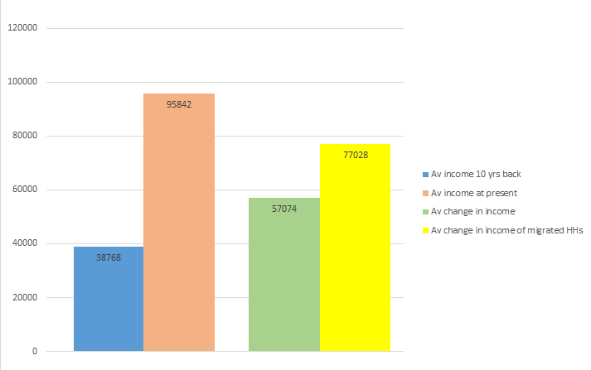
The annual income of average households has more than doubled in the last ten years, while income augmentation has been more significant for households having at least one of its members working outside. However, if adjusted against inflation since 2009, the average income of the respondents becomes 57,505 INR (assuming 60% inflation in the last ten years). This amounts to around a 50 per cent increase in real income, which in any case is significant and have obvious reflections on their consumption patterns.
The study observes that the principal factor behind the enhancement of earnings has been a migration of a large number of people from this region to different cities and towns, which opened many new avenues of income generation and increased their household earnings. Although many among these migrants had subsequently come back and settled in the villages, a substantial portion of the male folk still work outside and send remittances to their families living in the Sundarbans. Among the 60 households under our study, 25 have their members staying and working outside. The remittances sent by them to supplement and add to the household income to a great extent.
- Changes in consumption pattern
- Consumption of own produce
Changes in the consumption of own produce determined by two factors. Firstly, land ownership. 32 of the 60 households has no land of their own, while the rest possess very marginal lands on which they usually produce a single crop during the monsoon. Secondly, all the families in this area at present receive subsidised cereals for their family consumption. Hence, even the land-owning families might not consume their own produces wholly and may keep a portion of their agricultural products to sell in the market instead of cash. The scenario was completely different ten years ago when the land-owning families of this area crucially depended on their farm produce for subsistence.
Hence changes in the consumption of own produce have little consequence on our study results, while the study notices the multiple implications of the subsidised food supply scheme on the Sundarban population. It not only provides food security for the whole year, but it also gives the landowners the opportunity to produce crops for sale and for others to save a significant amount of their income that earlier used to be spent in buying rice, wheat and sugar. All residents of Sundarban have been receiving rice and wheat at nominal prices of Rs.2 per kg as a relief measure since 2009, thus saving much of their income that can now be used for buying other items, both food and non-food products from the market. This is why many of the respondents opined that Aila had been a blessing in disguise.
- The share of present consumption expenditures of food and non-food products
The study shows that presently a little more than half of the household expenditures in this area is being spent for buying non-food items, while on an average 6.5 per cent of total food expenses are spent for buying packaged food and beverages. The overall trend in consumption pattern is to spend more on buying non-food products and packaged foods. The percentages of expenditures for basic food, packaged food and non-food products in the total household expenditures are given in the pie-chart below:

In the present context, one of the most important indicators of consumption behaviour is the purchase of mobile phones or possessing the same. It seems significant to note since when (i.e. how many years ago) did the respondent or any member of his/her household purchase or possess a mobile phone. The data reveals that of the 53 households possessing mobile sets, all except three purchased a set within the last ten years, while 39 of them purchased a mobile within last five years and 12 during the last one year. So the rate of purchasing mobile seems to be increasing with time.
- Changing consumption pattern of food and non-food items
Then the study takes note of the change in the behaviour of the consumers in buying food and non-food items from the market, taking responses whether the households’ consumption of the main food and non-food items were lesser or higher or the same ten years back.
Among the food items, consumption of rice-buying from the market had been higher or the same in most cases 10 years ago, as at that time subsidised rice was not available. Consumption of other essential food items like fish ten years back had been mostly lesser or the same. For packaged food and beverages, most of the households had either no or insignificant consumption ten years ago.
The substantial reduction in expenditures in essential food items has increased the consumers’ capacity to purchase non-food products as more than 50 per cent of the respondents are reported to be spending more on basic non-food products and services like clothes, footwear and medical services.
The chart below reflects the percentage of monthly expenses for different non-food products on the total non-food expenditure of an average respondent. Remarkably, the highest share among non-food expenditures goes to medical expenses, followed by private tuitions, clothing, cooking gas, cosmetics etc. With the increase in income, these rural families are spending more on health and education, signifying an important change in consumption priority.

Remarkably, consumption of some items, such as medical, private tuitions, cosmetics, mobile and TV recharge and cooking gas that have major shares in non-food consumptions were either non-existent or insignificant ten years back. Consumption of these items has played the leading role in boosting the market.
So it is no wonder that 55 out of the 60 respondents reported that their family expenditure has increased during the last ten years, while 47 reported that they are aware of the new brands available in the market. 56 respondents said that their standard of living has improved in the last ten years. When asked to name about the new products they are purchasing nowadays, the respondents named four products on an average; the mobile set is the most common among them.
Let us now examine the factors influencing the consumption patterns of the households.
- Factors influencing changes in consumption pattern
The table and chart below provide the principal factors influencing the consumption behaviour as cited by the respondents.

Table III: Factors influencing the consumption pattern of the respondents
Factors influencing consumption the most | No of respondents
Market exposure | 27
Market availability and convenience | 6
Demand from children and family and availability | 16
Advertisement and availability | 11

The following figure shows the percentage of responses regarding factors influencing consumption pattern the most.

Notably, most of the respondents (55%) have mentioned market exposure and market availability as the most important factor for their change in consumption pattern. The 18 per cent who have mentioned advertisement as a most important factor influencing their choices clubbed it with availability factor. That means interactions with the local markets play the most crucial role in influencing the consumption of the local population.
So it is important to have a look at the nature of growth of the markets in this region and the underlying tension between demand and supply determining the characteristics of the markets.
- Market characteristics
Among the three markets taken for study, Gosaba market is situated at the block centre, while the two others are located at comparatively remote sites. The total number of shops and conditions of the shops reflect the difference between markets at the block headquarter and the remote places.
Table IV: Condition of shops in the three markets
 | Gosaba Market | Bally market | Kalitala market
No of shops | 376 | 132 | 120
Pucca shops | 376 | 60 | 30
Semi-pucca shops | 0 | 35 | 80
Mud shops | 0 | 37 | 10

It is reported that during the last ten years most of the shops in all the markets have either became pucca or semi-pucca, indicating the apparent prosperousness of the shop owners, gained in more recent period motivating them to invest more in their shops than what they used to do ten years back. The big shop owners are said to have an average investment of up to 20-25 lakhs of rupees, while the small shop owners’ investment would be around 5-15 lakhs, and for the average vendors on thelas or people doing business sitting on the ground, investment ranges between rupees 5000 to 2 lakhs. This rough assessment of investment include both fixed assets and running capital.
Evidently, the number of shops has increased to a great extent over the last ten years. All kinds of shops have increased in number. However, the shops of electronic and electrical goods, mobile recharge, cloth and footwear, beauty parlour, photo studio and photocopy, medical store, jeweller’s and stationery shops have increased in numbers and flourished economically. Fish and vegetable vendors have also increased significantly. While the increase in the number of shops dealing with electronics is the most common phenomena everywhere, increase of other shops reflects increased purchasing capacity of the local population during the last ten years.

The following table shows the nature of new shops that had come up in the three markets during the last ten years.
Table V: Nature of new shops that have come up in the last ten years
 | Gosaba Market | Bally market | Kalitala market
No of new shops | 30/35 | 30 | 55
Nature of new shops | Mobile, electronics, saloon, medical, cyber café and books and  stationery etc. | Medical, furniture, electronics and mobile, cyber café, hardware, stationary etc | Electrical and electronics, garments, beverages, hardware etc.

In the interactions with the shop owners, the following points emerged as their observations and reactions about the changes in the market condition and consumer behaviour that have taken place in the last ten years:
- The number of shops has increased phenomenally, and road conditions improved a lot. Most of the shops have turned brick-built and got connected by electricity. Overall improvement has taken place in the market environment.
- Demands and sales have increased enormously. Choice and preferences of products are fast changing and seem to be endless.
- The choice and tastes of the local people have improved as a whole. People have more money in hand, and with increasing purchasing power they are opting for better quality products.
- Local people have become more aware and conscious about products. They now prefer to buy quality products even at higher prices.
- Due to better communication, many people now go to distant markets (people from Bally Island coming to Gosaba market and Gosaba people visiting the Canning market) affecting the sale of the local market. Earlier they used to come to the market on foot. Now with the improvement in road conditions and conveyance facilities, people can travel to other markets at a distance.
- Many shop owners have changed to newer items depending on the customers’ choice and demands. As, a tea stall owner now keeps cold drinks and packaged foods like potato chips to attract more customers, particularly from the younger age group.
- Customers believe that quality would be better if they buy costly items. People are greatly influenced by TV advertisements. Women and girls are increasingly rushing for cosmetic products and beautification.
- Earlier people were more guided by their basic needs. Now people are guided by their constructed choice and more attracted to fashionable items.
- In Gosaba (a small block town) many people are purchasing online, hampering the local business to some extent. This feature has a lesser impact on other markets.
- In all the markets, commodities have to be transported from towns first by truck and then by boat. The absence of modern loading-unloading system during the boat transport, in particular, exposes the commodities to the risk of damage due to improper handling and getting wet in case of rain or leakage of the boats. It also increases the cost of transport.

- Discussion
The basic factors facilitating the changes in consumption pattern in this area are the significant increase in earnings of the local population and the subsidised food supply scheme since 2009. Apart from migration of a sizable section of the local population, improvement in the mode of conveyances with the construction of a river bridge connecting these islands with a railway station has enabled the local people to travel to Kolkata city and other towns making it possible for the local people to daily commute to the towns for different kinds of livelihood works and come back. These are principal factors behind enhancing the income generation capacity of the local population.
With considerable enhancement in family earnings boosting the purchasing power of the households, consumptions of nutritious food like fish and packaged food and beverages have increased along with the basic non-food items like clothing and footwear. The study reveals that the families of this area are now spending more on the purchase of many new products and services while fulfilling their basic needs in a greater way. As, expenditures for toiletry, cosmetics and beautification (together amounting to 10% of the monthly spending) are growing an emerging trend in the new generation. At the same time, spending for essential items and services like cooking gas and medical treatment (together amounting to 37% of the spending) have occupied a large share of their monthly expenditures. With growing financial capacity and improved conveyance system, local people are now moving to the towns for modern treatment, which was not possible earlier. Similarly, monthly expenses for TV and mobile services (10%) seems to be growing with the improvement in the financial health of the locals.
It may be worthy to note here that the local guide of our study, a youth having master degree and teaching in a school as para-teacher (receiving Rs.8000 per month as salary) apart from giving tuitions to school students, stated that, “I use to search google regularly to update my knowledge about the varieties of upgraded smartphones coming in the market and dream of buying a better one as soon as I can save enough money to so.” This, in brief, characterises the consumer behaviour of the educated youths in this region, which is still lacking in many basic amenities like electricity and road connections and a gas supply system.
It is needless to say that in these remote villages, people have to confine their choices mostly on the availability of products in the local market due to inaccessibility of town markets by road. The expression of the household respondents that their consumption pattern is largely determined by market exposure and the availability of different products there denotes a complex relationship between the emerging markets and changing consumers’ choice.
The study reveals an underlying tension between the demand and supply of newly introduced products and services. While the respondents mentioned market exposure and availability of products in the shops determining their choice of products, the shop owners seem to be perturbed by the changing choice and preferences of the consumers as they express little annoyingly that people are nowadays getting more influenced by TV ads. The shop owner’s comment that ‘choice and preferences of products are fast changing and seem to be endless’ seems to reflect a bit of frustrating in the face of demanding consumers.
It seems natural that people’s aspirations for new products and services are more influenced by TV ads and network searching than any other things and they would seek newer products in the local market. It is also natural that being located in remote areas with no land connection with the towns; shop owners would not be in a position to meet the ‘fast changing and endless’ choices of the customers. So the interaction between the customers, particularly of the new generation and the market, would not be smooth as it happens in city markets as the shop owners in such remote areas may not often be acquainted of the new generation products, for which the new generation educated youth would be aspiring. This study reflects the palpable gap between the ever-growing and fast-changing (and sometimes unpredictable) aspirations of the consumers and supply of products and services in the local market.
Conclusion
It is rightly inferred that rising rural monthly per capita expenditure (MPCE) is a reflection of India’s economic growth (Sethia, 2013) and increased incomes in the hands of the poor, will generate a rapid increase in the demand for consumer goods (Surendran, 2015). The present study reveals that the remote areas of coastal West Bengal, the Sundarbans, has been witnessing significant changes in consumption pattern during the last one decade. However, due to its remote location and geographical disadvantages, these Sundarbans villages are lagging behind the national average of changes in the consumption pattern so far as shares of consumption of food and non-food items in their monthly expenditures and share of packaged food in total food expenses are concerned.
The aspirations and demands, in particular of the women and the younger generation, are being constructed by the ever-expanding ad and digital world, while their consumption is restricted by the availability of products in the local market. This emerging gap between demand and supply might be resolved by further advancement in transport and communication services that can be met by more infrastructural development.
The principal reason behind the relatively slow change in the consumption basket of the people in the Sundarbans region is the slow pace of growth of the local economy because of several factors, the principal being its typical disadvantageous geographical location, although the socio-economic scenario has changed substantially in the last 10 years, bringing in its wake considerable changes in the consumption pattern of the local population.
Large-scale migration and government intervention through the supply of subsidised food scheme along with some infrastructural development may be construed as the main driving force behind these changes. However, more development in the infrastructural sector (construction of more roads and bridges, more electrification, irrigation facilities and creating more employment opportunities etc.) would boost the local economy and expedite changes in the consumption pattern of this region. Last but not the least is the development of basic facilities like proper health and education services, lack of which drives the local people to spend a considerable amount of their income (together 40%) for these facilities. Had there been adequate government health facilities and good educational institutions, people could have spent more money on buying other utility goods and services further boosting the market.
References:
Amir Zeeshan & Ali Ghufran (2015), Changing Lifestyle and Consumption Patterns of Indian Rural Households: An Analytical Study, International Journal of Trade & Commerce, January-June, Volume 4, No. 1.
Golait Ramesh and N. C Pradhan (2006), Changing Food Consumption Pattern in Rural India: Implication on Food and Nutrition Security, Ind. Jn. of Agri. Econ.Vol.61, No.3, July-Sept.
Gupta Sonika and Kalpana Singh (2016), An Analysis of Changing Rural-Urban Consumption Pattern in India, IOSR Journal Of Humanities And Social Science (IOSR-JHSS) Volume 21, Issue 9, Ver. 8
National Family Health Survey (NFHS-4) West Bengal 2015-16 (2017), International Institute for Population Sciences, Mumbai.
Sethia Savneeth (2013), India’s Changing Consumption Pattern, GYANPRATHA-ACCMAN Journal of Management Volume 5 Issue 2.
Surendran N, B. Mathavan (2015), Changing pattern of Consumption Expenditure in India,
Language in India, www.languageinindia.com, Vol. 15:7.

